ST. XAVIER’S COLLEGE

**(Affiliated to Tribhuvan University)**

**Maitighar, Kathmandu**



**Database Management System**

**Theory Lab Assignment #4**

**SUBMITTED BY:**

**Siddhant Rimal**

**013BSCCSIT039**

**SUBMITTED TO**

|  |  |
| --- | --- |
| **Er. Sanjay Kr. Yadav**  **( Lecturer )** |  |
| **Department of Computer Science** | |

Submission Date: August 10th 2015

1. **ER Diagram with one case study**

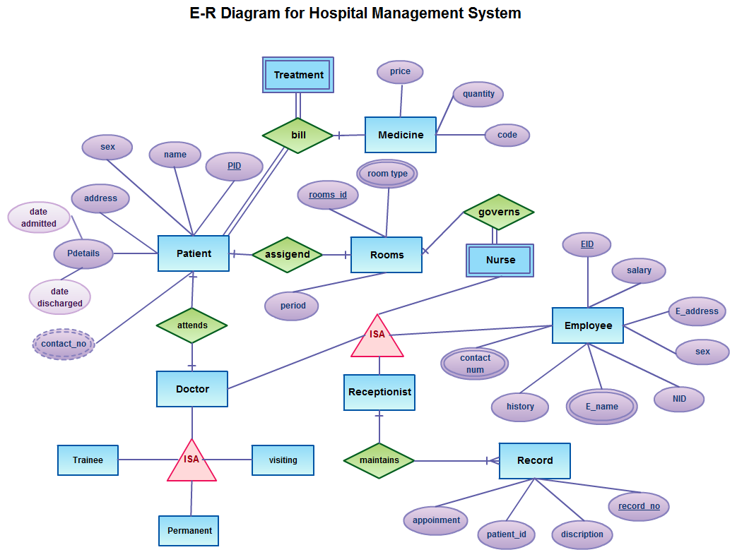

Fig.4.1: E-R Diagram of Hospital Management System

1. **Design**
   1. **Functional Design**

Functional design is the paradigm used to simplify hardware and software.  
The functional design of the hospital management system can be defined as follows:

* + 1. **Patient:** This module handles all the data records maintained for the information about patient such as Patient ID, Name, and Address etc.
    2. **Rooms:** This module handles all the information about the availability and maintenance of hospital rooms. It deals with room type and assigned rooms to respective patients.
    3. **Doctor:** This module deals with the information records about doctors working in the hospital. It can form a relationship set with which patient the doctor should attend and such information.
    4. **Trainee:** This module deals with the information deals with the information about all the trainees that attend the hospital premises and use hospital resources for training purposes. They are handled by a doctor that is assigned to them.
    5. **Visiting:** This module deals with visiting and guest lectures provided to the trainees and staff.
    6. **Permanent:** This module deals with record about permanent staff.
    7. **Receptionist:** This module handles other relationship sets like ‘maintains’, which relates to Records module. It also keeps information about Nurse, Doctors and other Employee.
    8. **Record:** This module maintains hospital records about upcoming appointments, busy schedule, description of patient and problem etc.
    9. **Nurse:** This module has total participation in ‘governs’ relationship set. Thereby, it is responsible to govern the assignment of rooms.
    10. **Employee:** This module stores information about other employees of the hospital. Employee records like Employee ID, salary, Name, Designation is kept.
    11. **Treatment:** This module has total participation in ‘bill’ relationship set. Thereby treatment only occurs when patient pays the bill.
  1. **Database Design**
     1. **Conceptual Database Design**
     2. **Logical Database Design**
     3. **Physical Database Design**

1. **Characteristics of Relations**
2. **ER to relational mapping algorithm**
   1. **Mapping of regular entity types**
   2. **Mapping of weak entity types**
   3. **Mapping of binary (1:1) relationship type**
   4. **Mapping of binary (1:N) relationship type**
   5. **Mapping of binary (M:N) relationship type**
   6. **Mapping of multivalued attribute**
   7. **Mapping of n-array relationship types**
3. **CONCLUSION**

* ER Diagrams play a very important role in the database designing process. They serve as a non-technical communication tool for technical and non-technical people.
* Entities represent real world things; they can be conceptual as a sales order or physical such as a customer.
* All entities must be given unique names.
* ER models also allow the database designers to identify and define the relations that exist among entities.

1. **REFERENCE**
2. [**http://www.guru99.com/er-modeling.html**](http://www.guru99.com/er-modeling.html)
3. [**http://www.slideshare.net/SafiUllah2/hospital-management-system-25384877**](http://www.slideshare.net/SafiUllah2/hospital-management-system-25384877)